
Mawlana Bhashani Science and Technology University
Sontosh, Tangail-1902
Department of Information and Communication Technology

Lab Report

Lab Report no : 04
Name of the report : Basic query of MySQL.
Course title : Database Management System Lab
Course code : ICT-2110

Submitted By | Submitted To
Name: Monirojjaman Ayoive  ID: IT-23013  2nd Year, 1st Semester  Session: 2022-2023  Dept. of ICT, MBSTU | Dr. Md. Abir Hossain  Associate Professor  DEPARTMENT OF INFORMATION AND COMMUNICATION TECHNOLOGY  MAWLANA BHASHANI SCIENCE AND TECHNOLOGY UNIVERSITY
Date of Performance: 05-01-2025 Date of Submission: 12-01-2025

Experiment No: 04
Experiment Name: Basic query of MySQL.
Objective: The main objective of this experiment is to use some basis query of MySQL. We will learn how to show different attributes from database and also learn how arithmetic expressions work in database.
Required Instruments :
- MySQL 8.3 Command line Client.

Finding the names of all instructors:
SQL expression: select name from instructor;

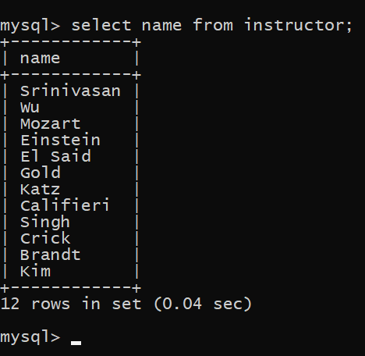

Finding the department names of all instructors:
SQL expression: select dept_name from instructor;
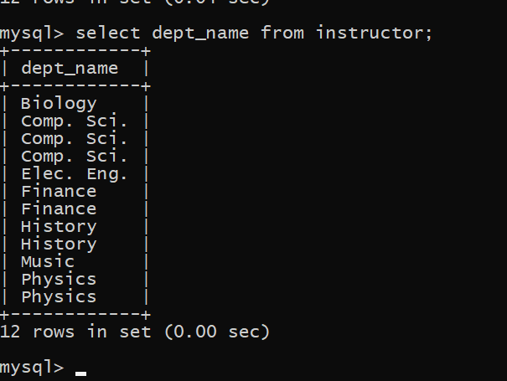

Finding the distinct department names of all instructors:
SQL expression: select distinct dept_name from instructor;
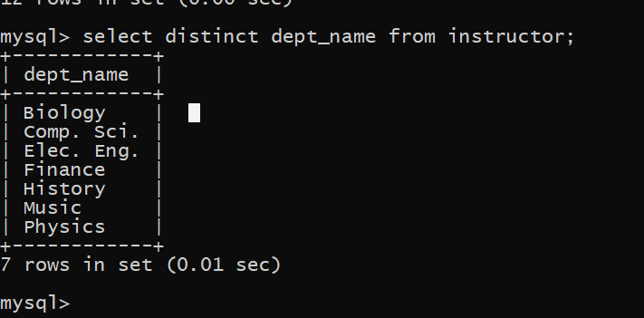

Finding the all department names of all instructors.
SQL expression: select all dept_name from instructor;

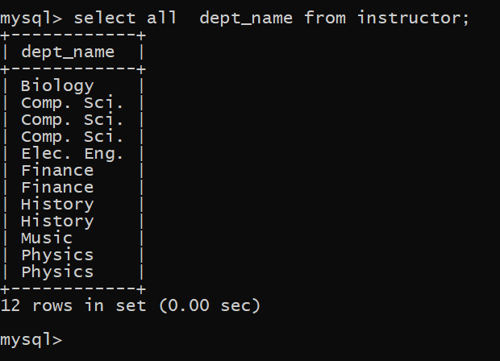

The select clause may also contain arithmetic expressions involving the operators +, −, ∗, and / operating on constants or attributes of tuples. For example, the query:
SQL expression: select ID, name, dept_name, salary *1.1 from instructor;
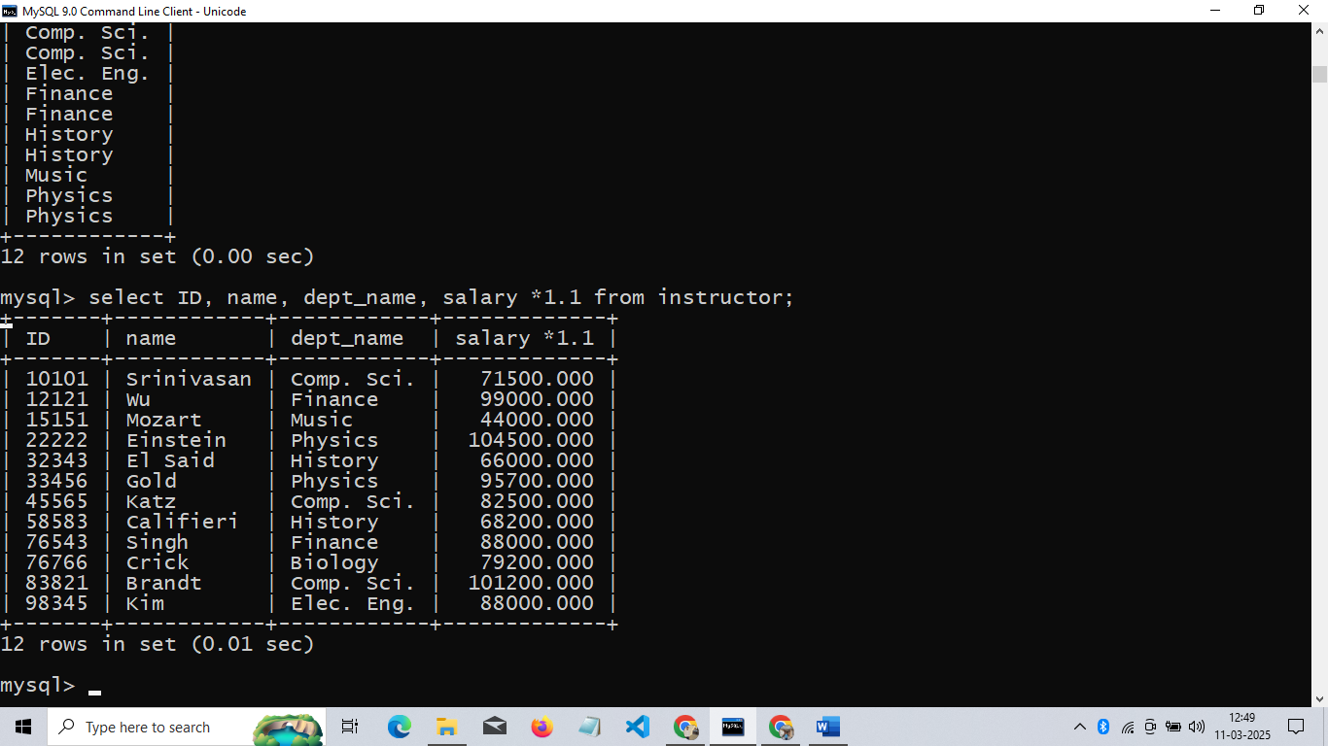
Finding the names of all instructors in the ICT department who have salary greater than 30,000:
SQL expression: select name from instructor where dept_name=”comp. sci.” and salary>70000;

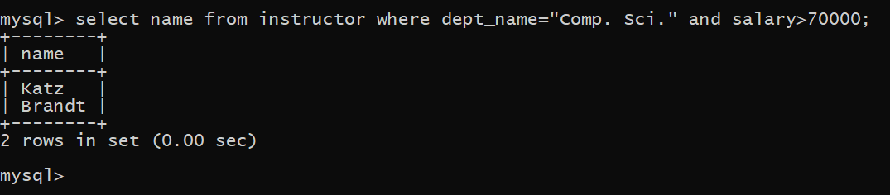
Finding the names of all instructors, along with their department names and department building name.
SQL expression: select name, instructor.dept_name, building from instructor, department where instructor.dept_name=department.dept_name;

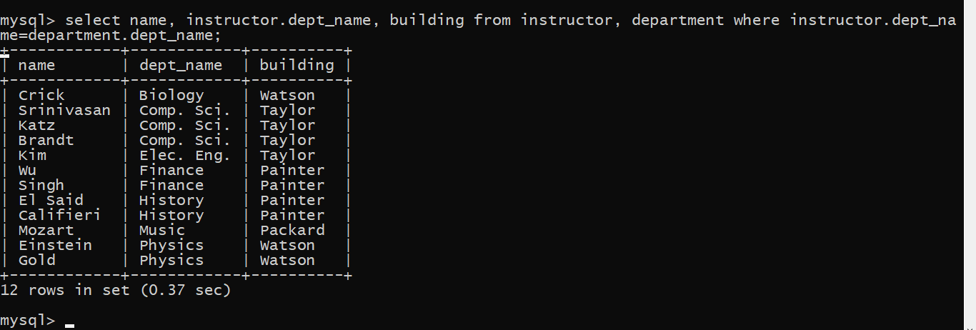
“For all instructors in the university who have taught some course, find their names and the course ID of all courses they taught.”
SQL expression: select name, course_id from instructor, teaches where instructor.ID= teaches.ID;

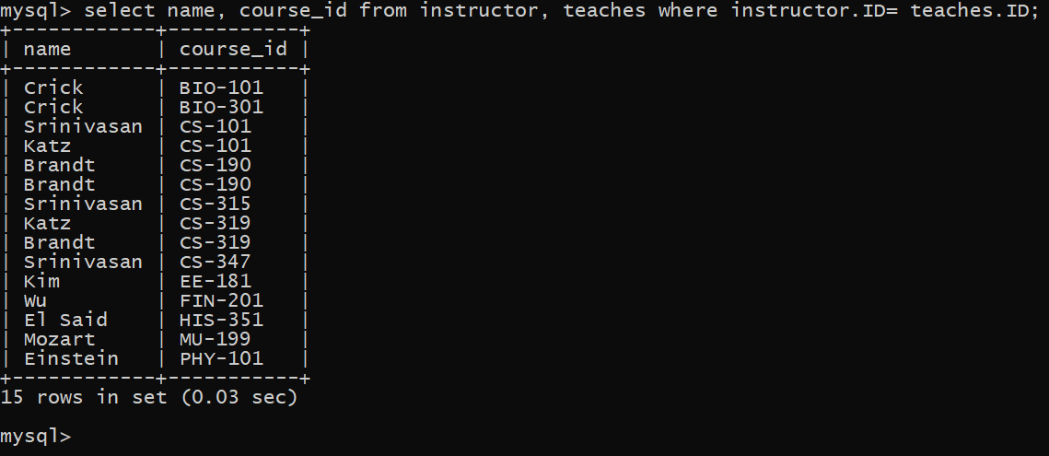

Find only instructor names and course identifiers for instructors in the Computer Science department.
SQL expression: select name, course_id from instructor, teaches where instructor.ID= teaches.ID and instructor.dept_name = 'Comp. Sci.';
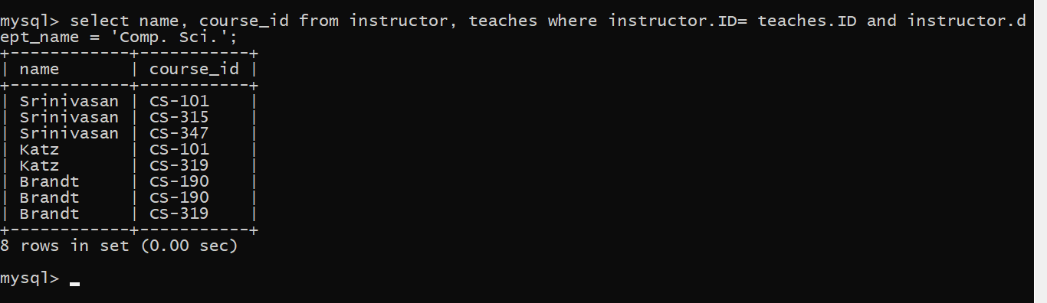
if we want the attribute name name to be replaced with the name instructor name.
SQL expression: select name as instructor_name, course_id from instructor, teaches where instructor.ID= teaches.ID;
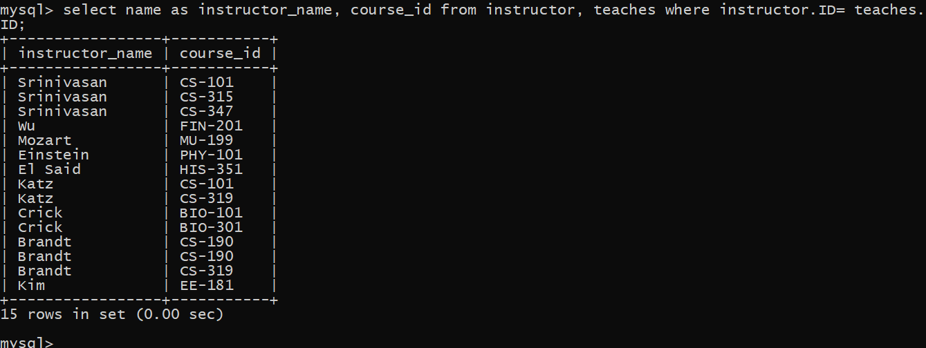

SQL expression: select T.name, S.course_id from instructor as T, teaches as S where T.ID= S.ID;
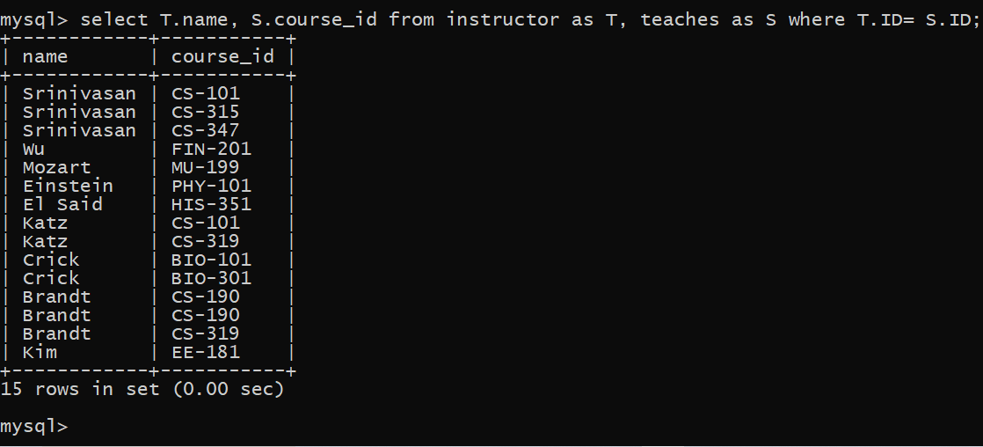
Finding the names of all instructors whose salary is greater than at least one instructor in the Physics department.
SQL expression: select distinct T.name from instructor as T, instructor as S where T.salary > S.salary and S.dept_name = 'Biology'; 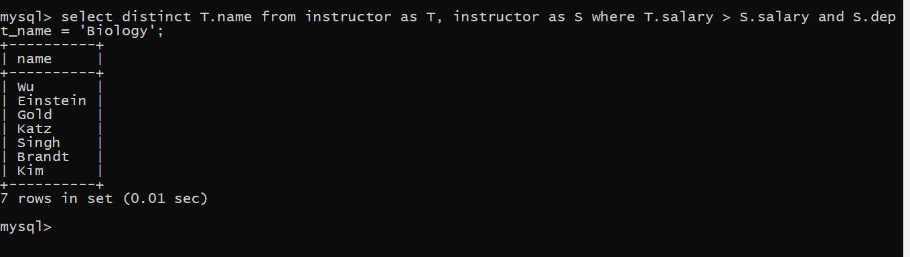
Finding the names of all departments whose building name includes the substring '1’.
SQL expression: select dept_name from department where building like '%watson%';
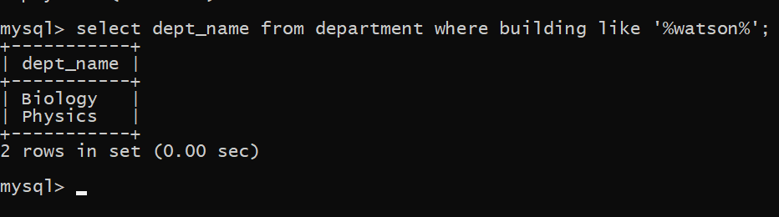

The asterisk symbol ‘*’ can be used in the select clause to denote all attributes. Herer is and example:
SQL expression: select instructor.* from instructor, teaches where instructor.ID= teaches.ID;
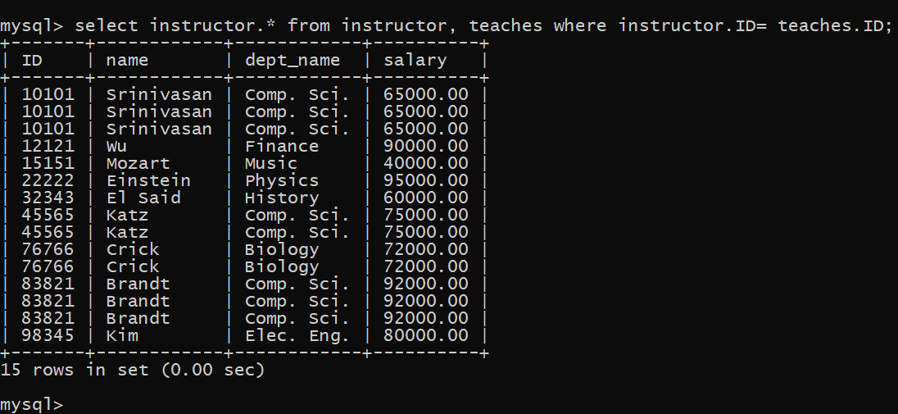

The order by clause causes the tuples in the result of a query to appear in sorted order. Here is an example:
SQL expression: select name from instructor where dept_name = ' Physics' order by name;
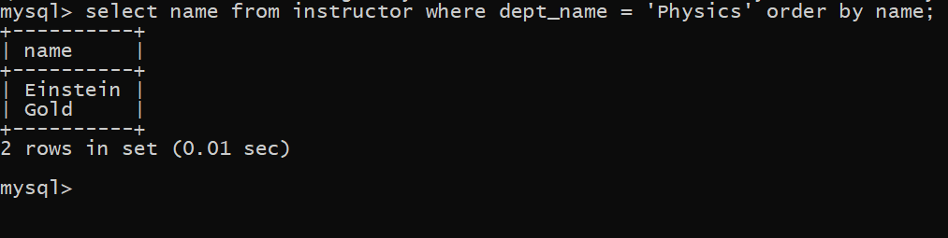
We wish to list the entire instructor relation in descending order of salary. If several instructors have the same salary, we order them in ascending order by name.
SQL expression: select * from instructor order by salary desc, name asc;
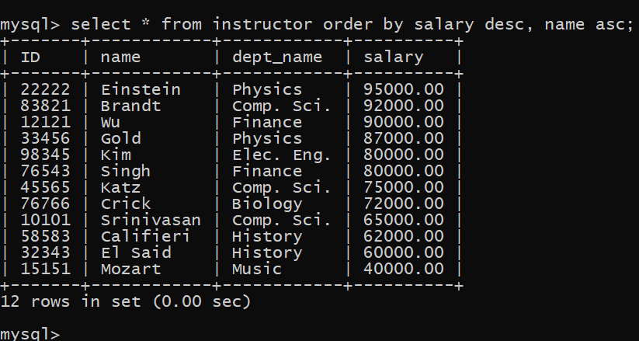
If we wish to find the names of instructors with salary amounts between 30,000 and 45,000. The query will be like this:
SQL expression: select name from instructor where salary between 30000 and 80000;
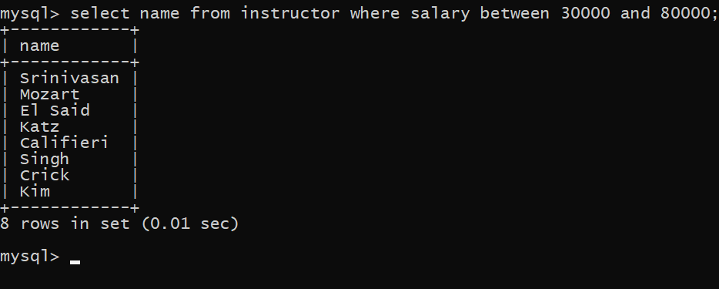
Finding all courses taught in the Fall 2017 semester but not in the Spring 2018 semester.
SQL expression: (select course_id from section where semester = 'Fall' and year= 2017) except (select course_id from section where semester = 'Spring' and year= 2018);
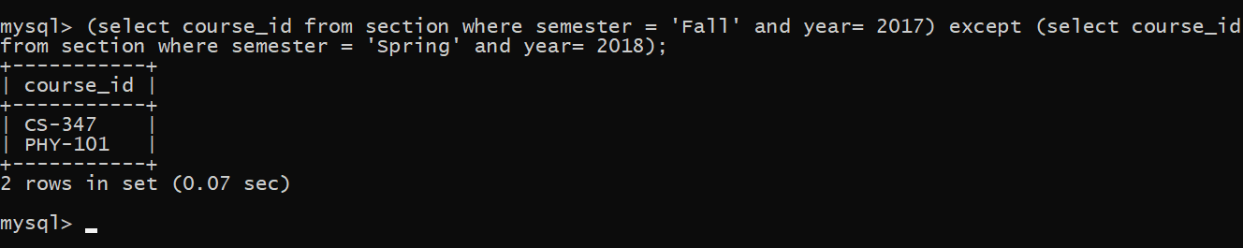
Finding the set of all courses taught in the Fall 2018 semester.
SQL expression: select course_id from section where semester = ‘Fall' and year= 2017;
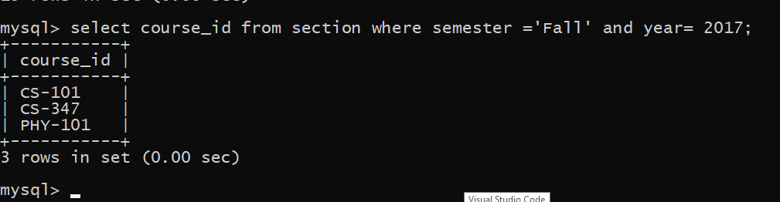
Finding the set of all courses taught either in Fall 2017 or in Spring 2018, or both.
SQL expression: (select course_id from section where semester = 'Fall' and year= 2017) union (select course_id from section where semester = 'Spring' and year= 2018);
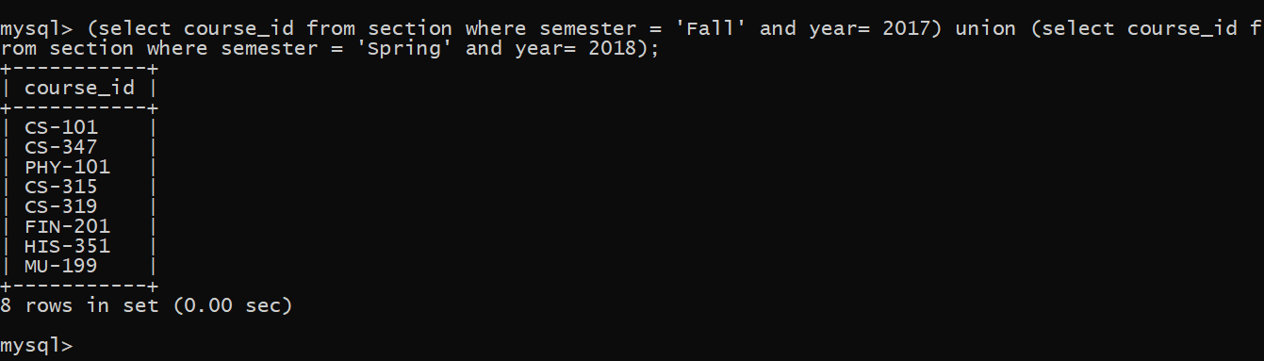

Finding the set of all courses taught in both the Fall 2017 and Spring 2018.
SQL expression: (select course_id from section where semester = 'Fall' and year= 2017) intersect (select course_id from section where semester = ‘Spring' and year= 2018);
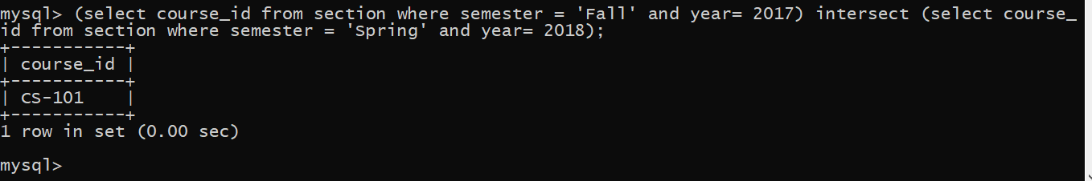
Finding all instructors who appear in the instructor relation with null values for salary.
SQL expression: select name from instructor where salary is null;
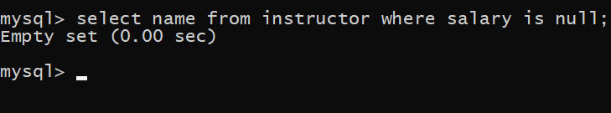

Finding the average salary of instructors in the ICT department.
SQL expression: select avg (salary) from instructor where dept_name = 'comp .sci.';
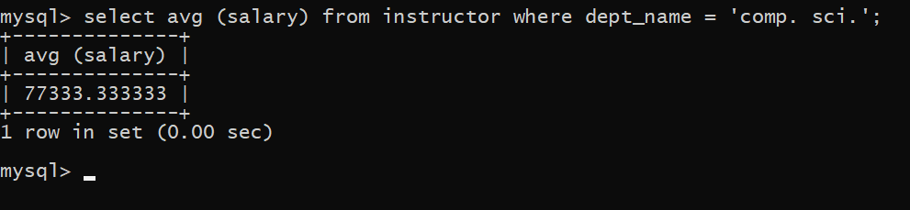

Finding the average salary in each department.
SQL expression: select dept_name, avg (salary) as avg_salary from instructor group by dept name;
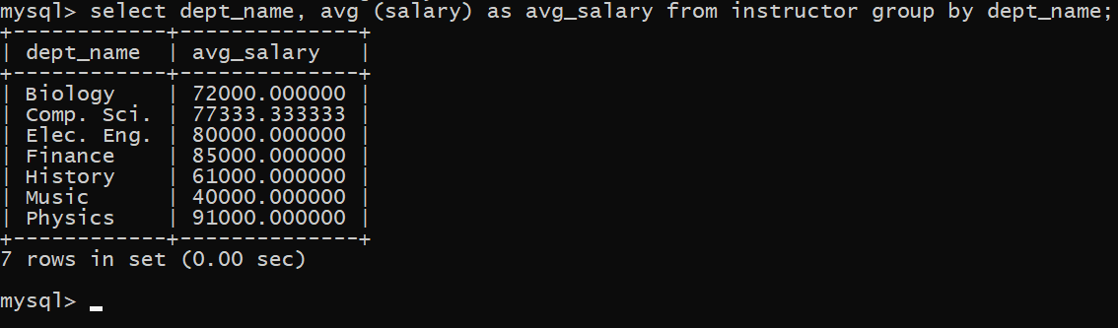
Find the average salary of all instructors.
SQL expression: select avg (salary) from instructor;

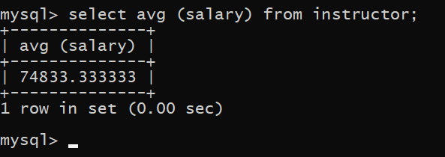

Finding how many teachers taught in Fall 2018 semester.
SQL expression: select count(distinct ID) from teaches where semester = 'Fall' and year = 2017;
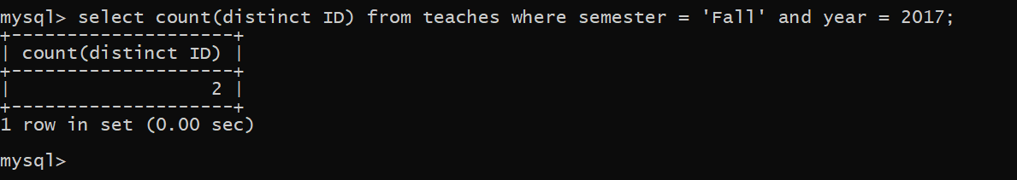
Finding the number of tuples in the course relation.
SQL expression: select count(*) from course;
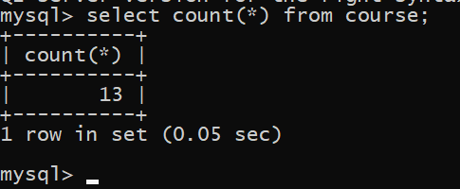
Finding the total salary.
SQL expression: select sum(salary) from instructor;

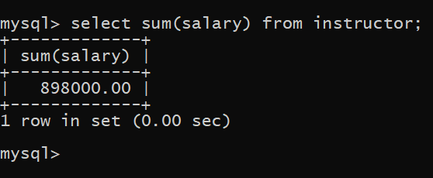

Finding the department name and average salary where the average salary of the instructors is more than 31,000.
SQL expression: select dept_name,avg(salary) as avg_salary from instructor group by dept_name having avg(salary)>31000;
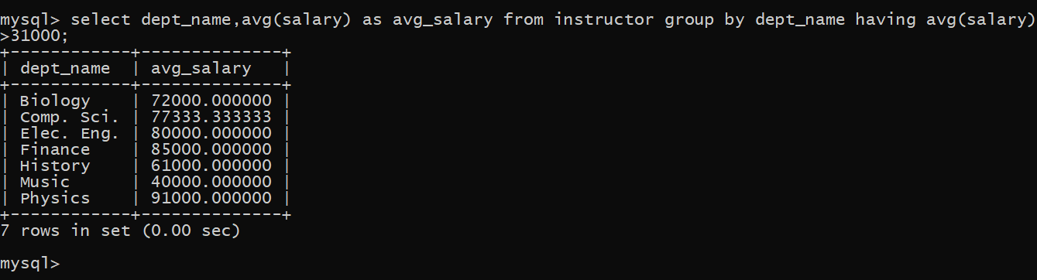

We wish to know the names of instructors whose names are neither “
Mozeret” nor “Einstein”.
SQL expression: select distinct name from instructor where name not in ('Mozert’, 'Einstein');
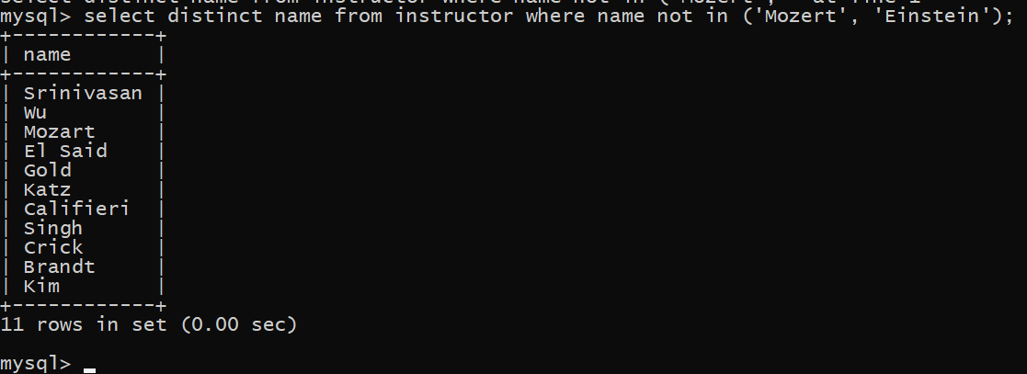
Delete all tuples in the instructor relation pertaining to instructors in the Finance department
SQL expression: delete from instructor where dept_name = 'Finance';
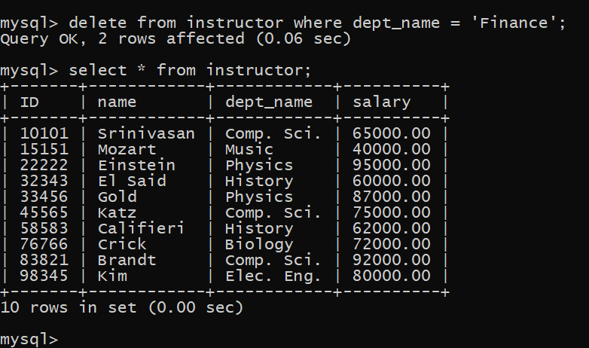

Delete all instructors with a salary between $13,000 and $15,000.
SQL expression: delete from instructor where salary between 72000 and 80000;
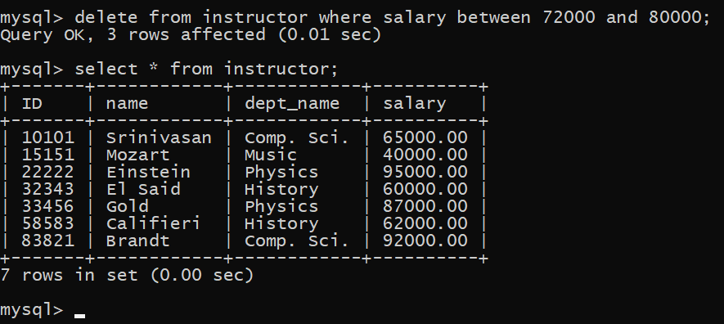

Delete all tuples in the instructor relation for those instructors associated with a department located in the Watson building.
SQL expression: delete from instructor where dept_name in (select dept_name from department where building = 'Watson');
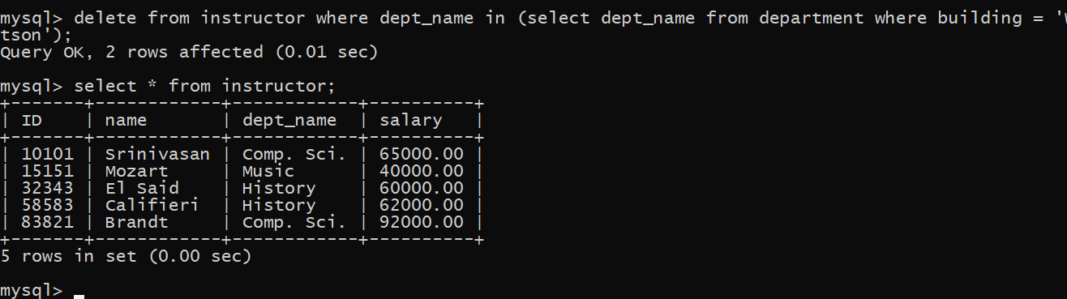
SQL insert statements are identical in function to the preceding one:
SQL expression: insert into course values ('CS-437', 'Database Systems', 'Comp. Sci.', 4);

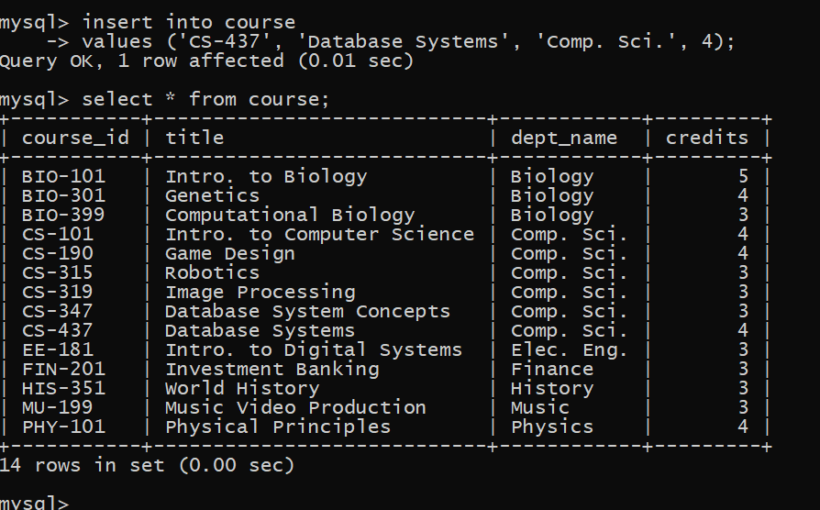

Suppose that annual salary increases are being made, and salaries of all instructors are to be increased by 5 percent
SQL expression: update instructor set salary= salary * 1.05;
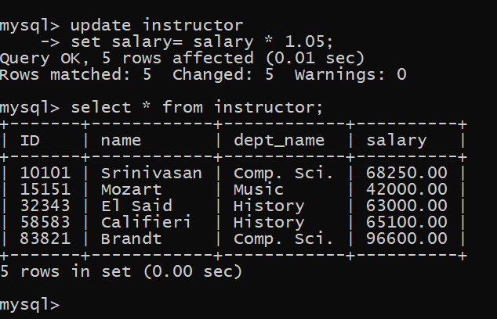

Discussion: From the above query we can easily find our desired attributes. We can command different types of queries to find any type of data set that we are looking for.

